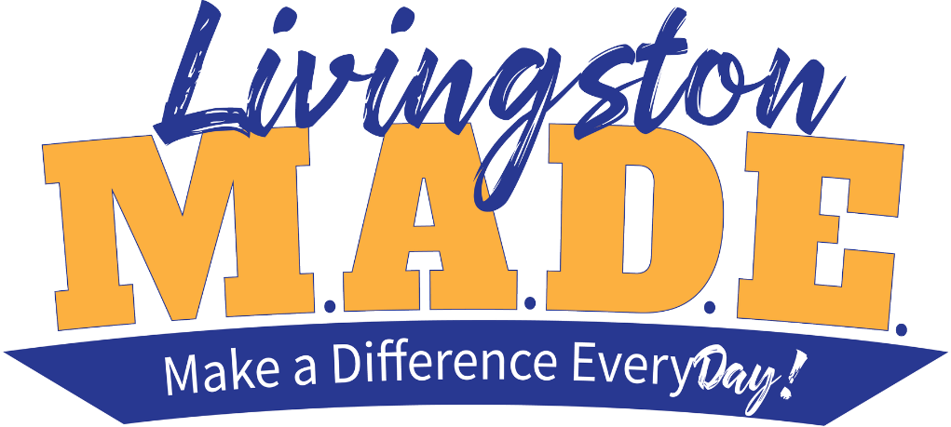

Laptop Care & Internet Safety Videos
These videos will explain how you can care for your take home device, as well as how to use the internet safely and effectively. Using devices such as laptops comes with many responsibilities. Please understand that LPPS laptops are expensive and should only be used for educational purposes by students. Your school laptop is property of Livingston Parish School District, and all users must follow district policy and relevant school policies regarding the device. District policy can be found at http://bit.ly/lppstechpolicy

Grades K-2 Youtube Playlist
Grades 3-5 Youtube Playlist
Grades 6-8 Youtube Playlist
Grades 9-12 Youtube Playlist

