With grades being due, it is imperative that a school administrator check teacher categories to ensure correct grading. This is a simple report run through PowerSchool. Here are the steps:
- System Reports
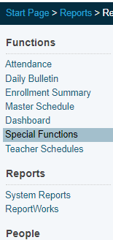

- sqlReports
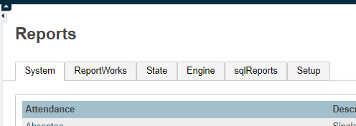

- Grades, then Category Total Report- By Section
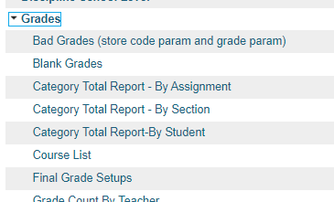

- Click “Submit” and see the next page for examples of correctly categorized assignments. Note: ONLY assignments categorized as ELA Block Reading (ELEM) or ELA Block Language (ELEM) will count towards a student’s grade.

EXAMPLES

Correct:

Incorrect:

Note: ONLY assignments categorized as ELA Block Reading (ELEM) or ELA Block Language (ELEM) will count towards a student’s grade.

To check if teachers have set up the correct category weights for their ELA classes, please run

System Reports >> sqlReports >> Weighting by Teacher and Term

